**User’s Manual**

Save the MGF file of the compound's mass spectrometry secondary fragments that need to be predicted to the folder where the EXE file is located. Click ‘GNN-FT-model.exe’ file. Then click the 'submit' button. After the file conversion is completed, 'The data have been split' will be displayed in the output box. After completion, click the 'Exit' button to exit.

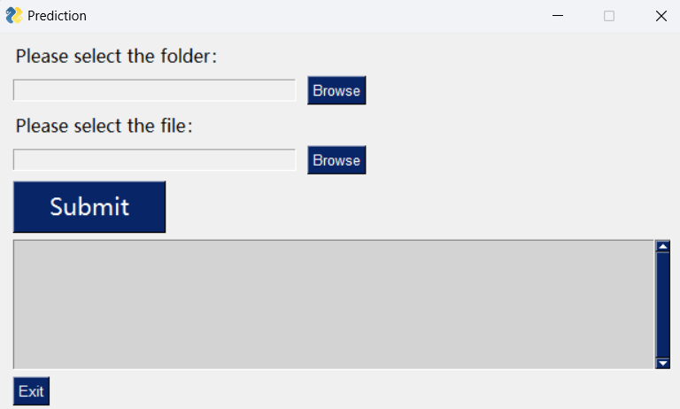

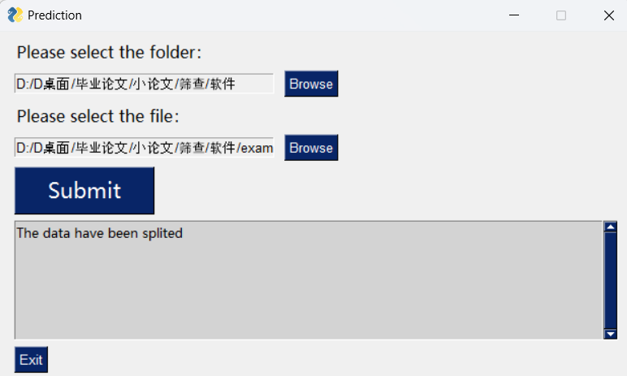

(1) If it is in positive ion mode, please click the run-ff0.bat file in the ./split/FT folder. This will automatically calculate the compound in the MGF file into fragment tree results. The fragment tree results will be in the ./split/FT/tree folder.

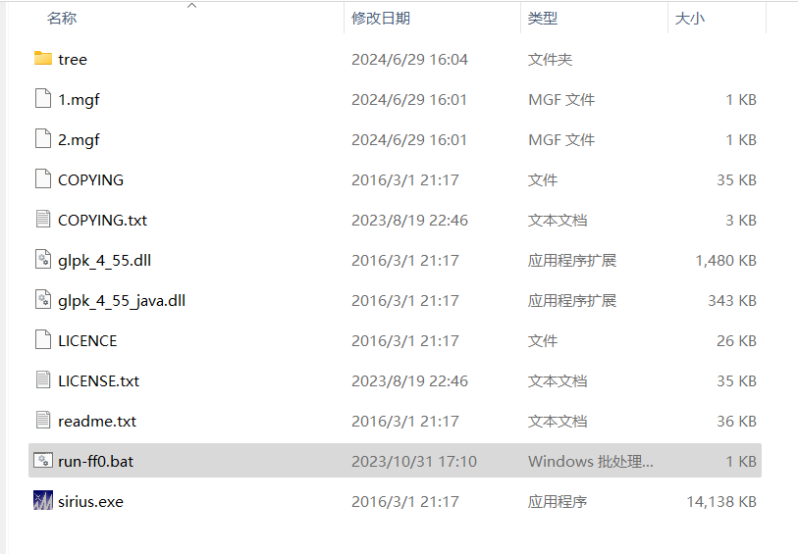

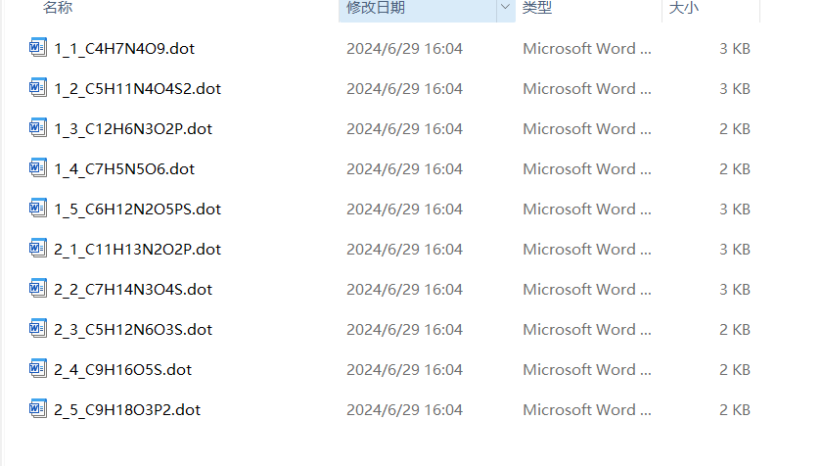

Then, in the pop-up interface, select Positive mode from the dropdown menu and click the 'OK' button to submit to the model for prediction.

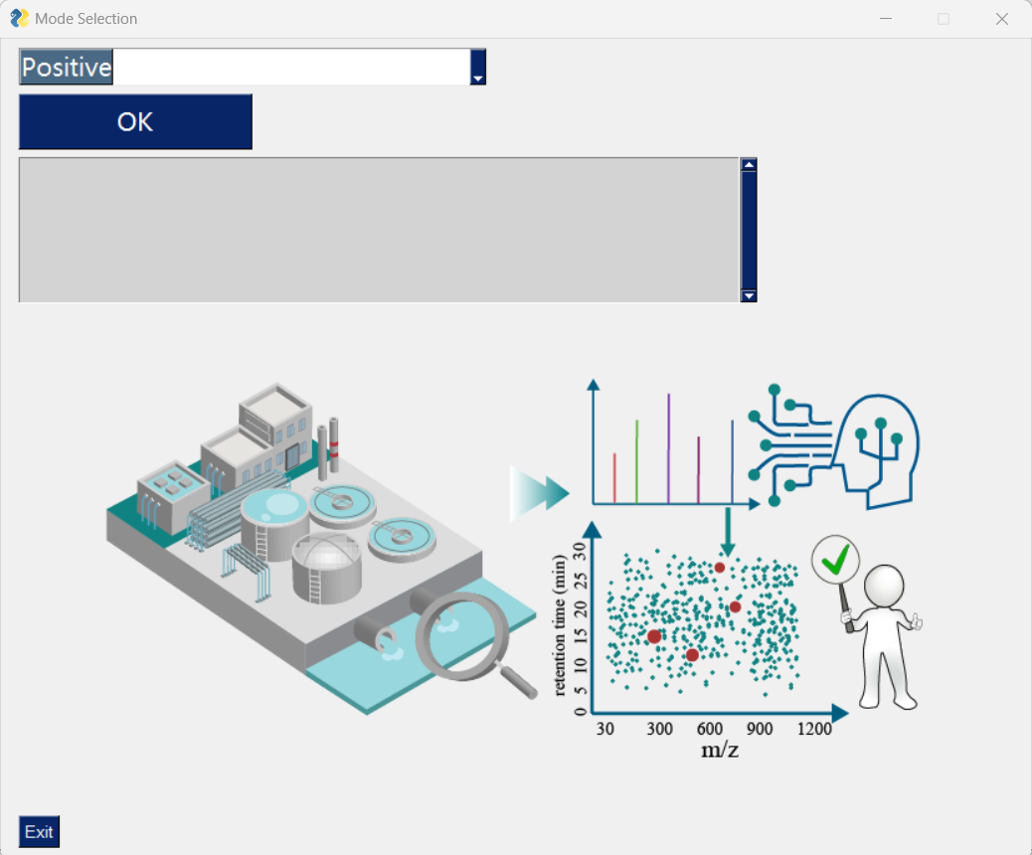

After the model prediction is complete, 'The predictions are saved to: ./df_positive_predict.xlsx' will appear in the output box.

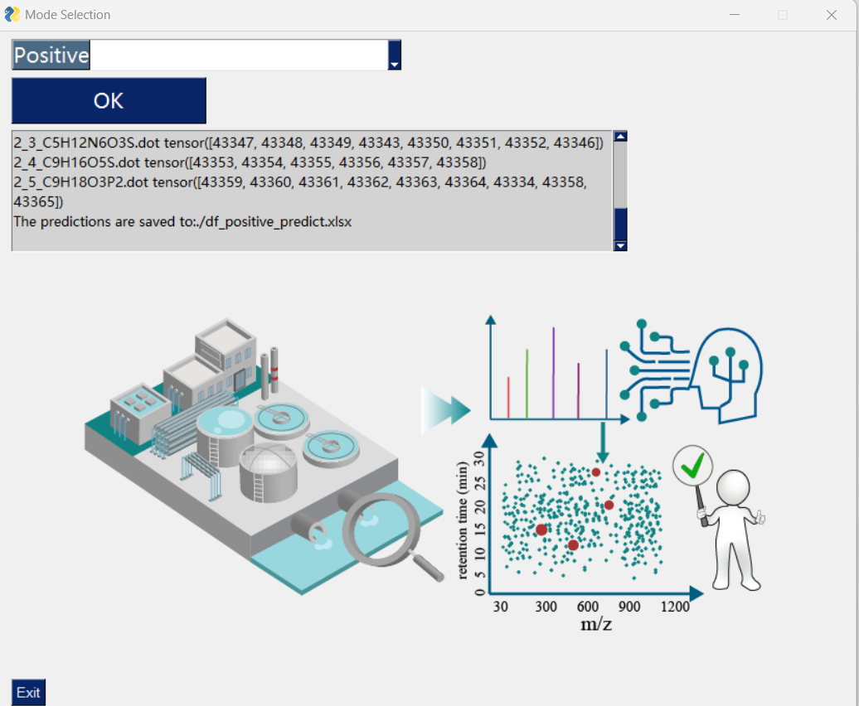

(2) If it is in negative ion mode, please click the run-ff_FP.bat file in the ./split/FP folder. If a password is required, press the enter key. This will automatically predict the compounds in the MGF file as fingerprints. The fingerprint prediction results will be in the ./split/FP/FP_AD folder.

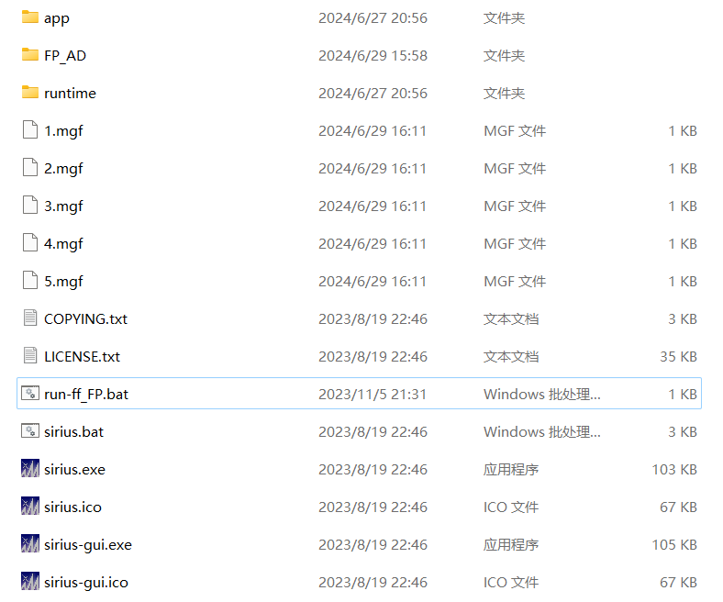

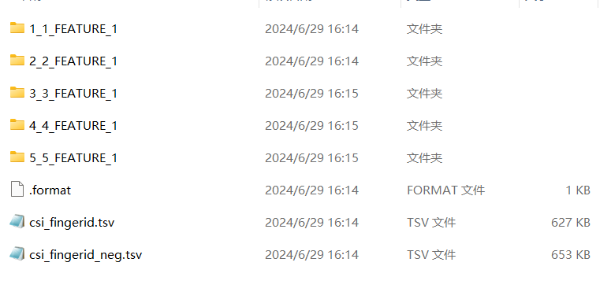

Then, in the pop-up interface, select Negative mode from the dropdown menu and click the 'OK' button to submit to the model for prediction. After the model prediction is complete, 'The predictions are saved to: ./df_negative_predict.xlsx' will appear in the output box.

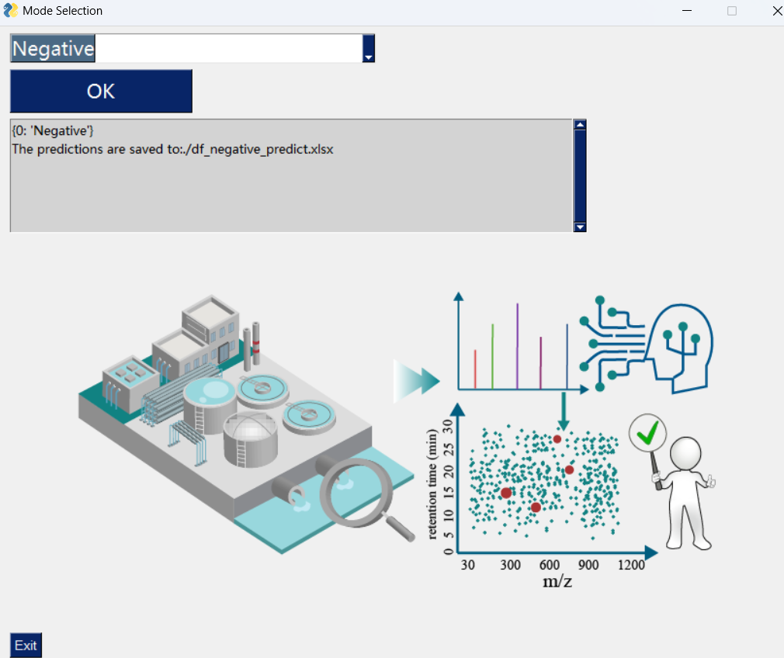

Note: Before starting a new prediction task, make sure to delete the generated MGF file, fragment tree files, and fingerprint prediction result files.